Newsletter of The Leeds Society of Model and Experimental Engineers
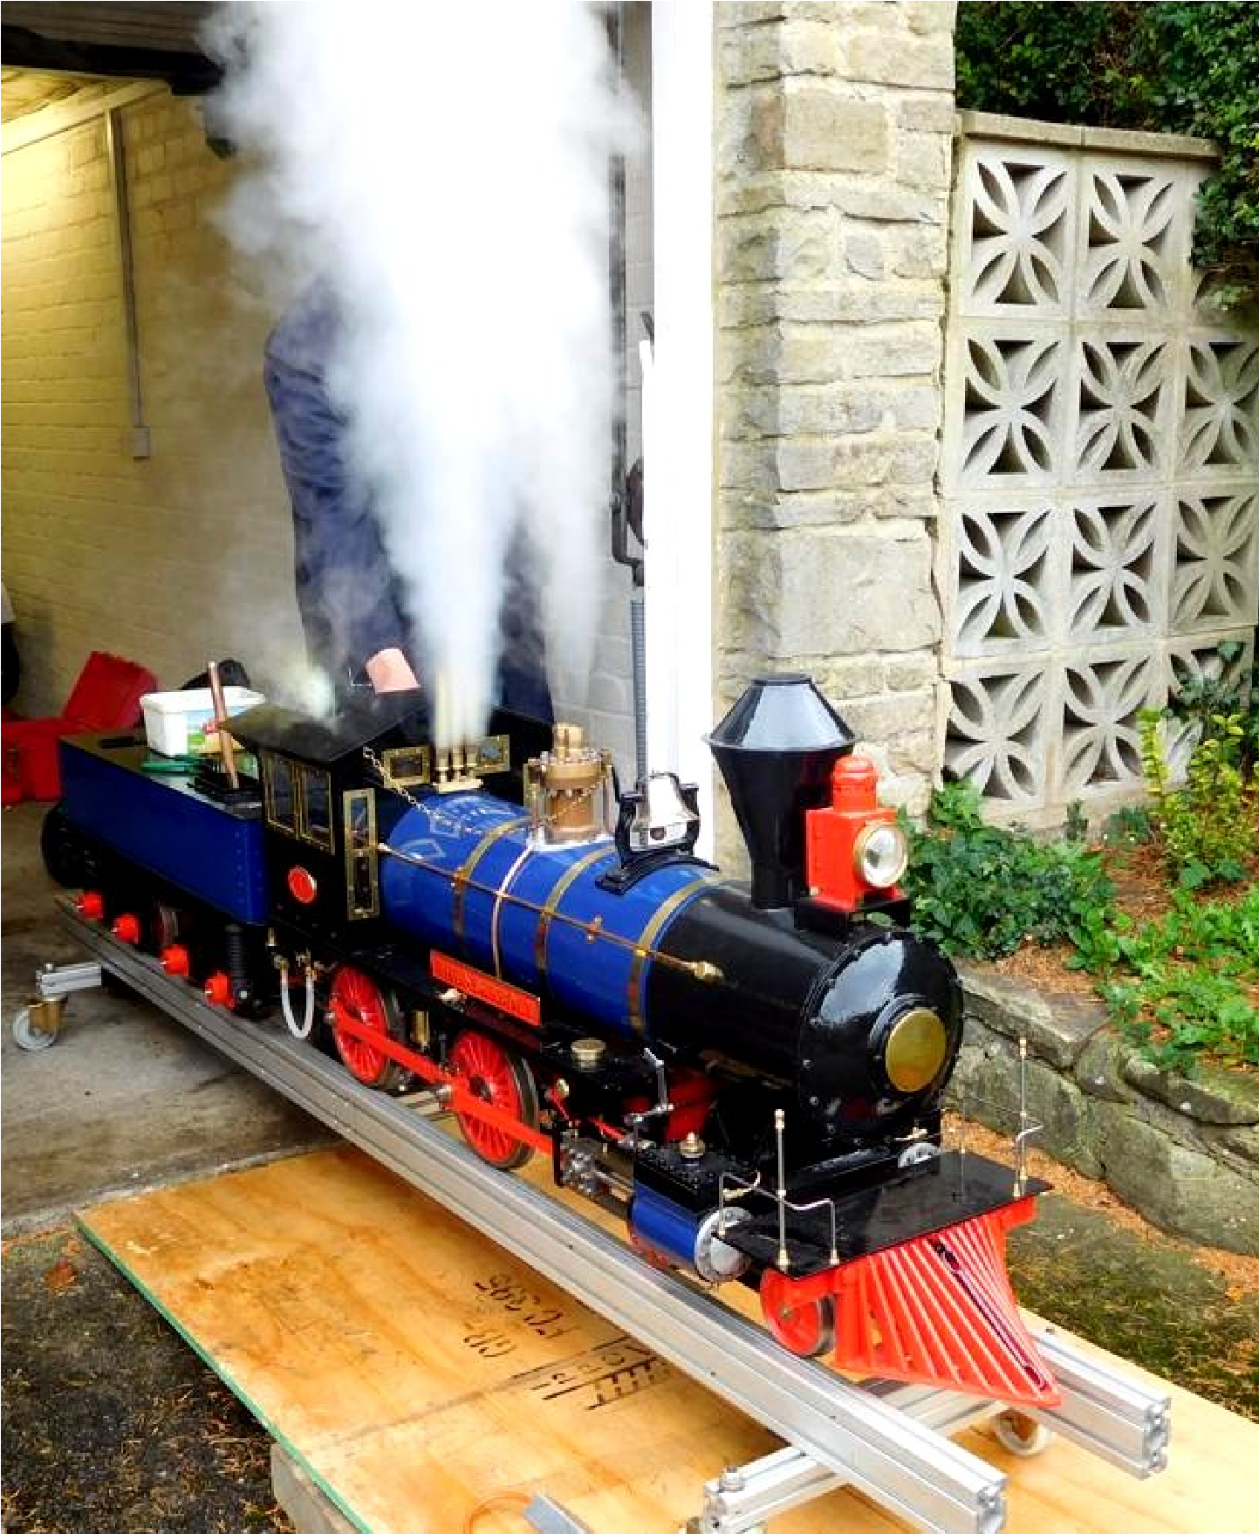

In this Issue

From the Chair 3
Terry Booth 4
Subscriptions Reminder 4
Portable Track 5 Injector Woes 6
Appeal for Information 8
An aid to screw-on chuck fitting 9
Club Clothing Bargains 10
Society Officers and Committee 11
Dates for your Diary Back Cover
Front Cover

Boiler Test for Thunderbolt
From the Chair John Hunt
First of all, may I wish you all a Happy New Year and that we can hopefully look forward to a year of well attended events and activities within the Society.
It seems ironic that last Christmas we were enduring restrictions on our movements and socialising and boldly saying, thank goodness it will be all over by next year. Unfortunately, we still seem to be in the same boat and still hoping a new year will be better.
In the present climate, the committee is meeting on a virtual basis. In the light of this I am a little reluctant to start up evening society meetings. We had hoped to re start them in January, but current levels of Covid infection would understandably result in poor attendance numbers and I feel that getting a speaker to turn out in front of people would be difficult.
The informal Monday breakfast get togethers at Darrington Golf Club and Wednesday evening natters at Drax Social Club still continue while restrictions allow.
One of the biggest new issues for 2022 is the issue of Driver Competency. A test has been devised to comply with the HS2020 – 'Managing Health and Safety at Passenger Carrying Miniature Railways’ guidance document. . On satisfactory completion, you will be given a card which can be shown to officers of any club to confirm your competency. Those interested in taking the test should approach any member of the committee.
The moves to rebuild a track are also gaining a pace as the committee met with officials of the St Francis group (the new owners of the Eggborough site) and made some positive moves to secure a track site in the near future.
We will be carrying out preseason checks on the portable track and trailer, hopefully in March. We are organising with the Drax manager to allow us to erect the track at Drax Sports and Social Club, combined with a breakfast meeting. It is hoped also that the boiler testers will be in attendance to carry out any tests needed for the coming season.
To close I would like to give special thanks to the outgoing committee members for their dedication and service. Geoff, Jack, David and Nick have worked tirelessly for the society over a number of years. Also to Geoff and Peter for keeping the society informed through the newsletter and website through challenging times and for the stalwart suppliers of entertaining content on the “virtual work on the table”. Nigel, Geoff, Roger and Alan being the most productive.
Terry Booth 1937 - 2022 Nigel Bennett
Although not a Leeds member in recent years, Terry Booth used to appear regularly at Eggborough Running Days, usually accompanied by a little terrier dog. He generally spent a few bob on the Bring & Buy stall at the August rallies, too. Living in Worksop, understandably he was also a member of the Chesterfield and Nottingham Societies. He was formerly an Architect for Bassetlaw Council. He had a variety of models; these included a steam wagon, a Merchant Navy, an A3 and I seem to recall a Britannia. He would often buy part-built models and work on them, sometimes parting with them before completion if something better took his fancy.
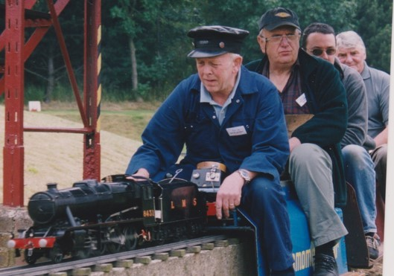
The only photo I could find of him was at IMLEC 2002, when he was tail-gunner to David Kerry and his 8F. (Phil
Turner was the Observer and Steve Eaton the third Chesterfield member aboard).
Terry leaves a wife Janice.
Thanks to Bill Holland for the information.
_*/Nigel's got the begging bowl out again!/*_
Members are advised that subscriptions are now due; at £20 they are a snip! Get yours now before they go up! And if you're under 18 - well at £2, what's not to like?
Nigel can be contacted via mail for cheques at
7 Swale Crescent, Garforth, Leeds LS25 2JA,
or push twenty quid into his hot sticky hand when you see him next. Alternatively, you can do a bank transfer to our account
Account Name City of Leeds SMEE
Sort Code 05-07-62, Account No 25136516
quoting your name as reference. Please drop me an email if you do this, as otherwise I'll only get to know about it when the next bank statement drops through my letterbox.
Portable Track John Hunt
After the threat of storm Arwen the day turned out to be fine but cold and the portable track had its first public outing for two years at Barkston Ash School.
You can see from the pictures that the track was on a mixture of grass and astroturfing and had a fair covering of leaves. The track went together easily and the club loco performed well.
Mark did most of the heavy hauling with his Sweet Pea and despite a two year lay off the loco was up to the task. The only problem was that we were wearing that much clothing we couldn’t bend to reach the controls. Mark had to strip a layer off to bend in the middle!
We were well looked after with coffee and sandwiches. All in all a good day to get us back into events.
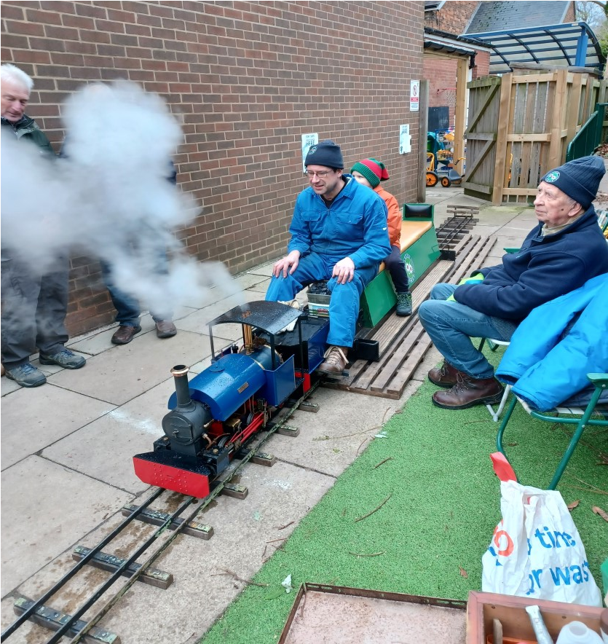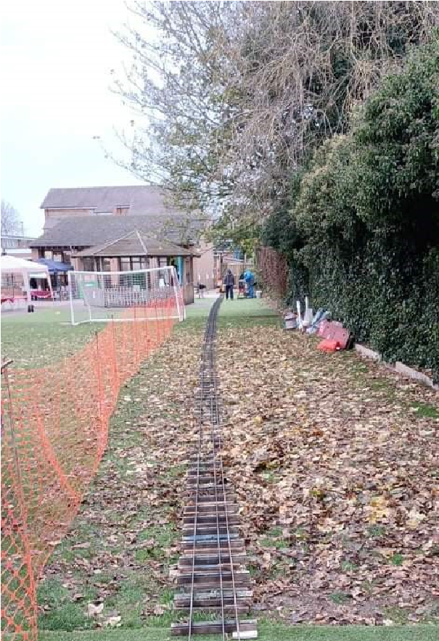
Pictures by Steve Harland
The first 2022 portable track event is a three day event at the Wensleydale railway on the weekend of 30th April to 2nd May. In order to give them confirmation that we can do the event it would be good to have some idea that we can staff it, so if you can help out on any of these days please contact me by email at johnhunt4472@gmail.com or by telephone (number on page 11).
If you don’t make a howling mess of things occasionally, you’ll never learn anything! Nigel Bennett
I needed an injector for Ashey. I’d built a couple for Cudyll Bach a few years ago, and they had worked. I had used DAG Brown’s body design but Basil Palmer’s internals and I was intending to do the same thing, but perhaps try one of Bob Ransom’s internals on a couple.
This time I used some 3/8” diameter Nickel Brass (Nickel Silver or German Silver are other names for the stuff) that I had in stock after an unsuccessful project at work. Well... it had been easier to throw the bar into my bag than in the scrap bin, because my bag was nearer.
The advantage of nickel brass for injector bodies, I thought, was that not only did I have the material, it was the same colour as silver-solder so the soldered joints wouldn’t show. I merrily turned up the body barrels, taking great care to get the lengths as accurately as I could, and drilling them undersize. I had learned from the earlier batch that you need to do the final ream to size after the silver-soldering operation to ensure it all cleans up nice and straight. The various protuberances were machined from the same bar, and I carefully assembled them into my brazing fixture. Screw threads were painted with Tipp-Ex (so solder didn’t stick) and flux applied to the joints. A blast with the torch, application of silver solder and a dunk in the pickle followed, the process repeated five times. Here’s one in the fixture after brazing:.
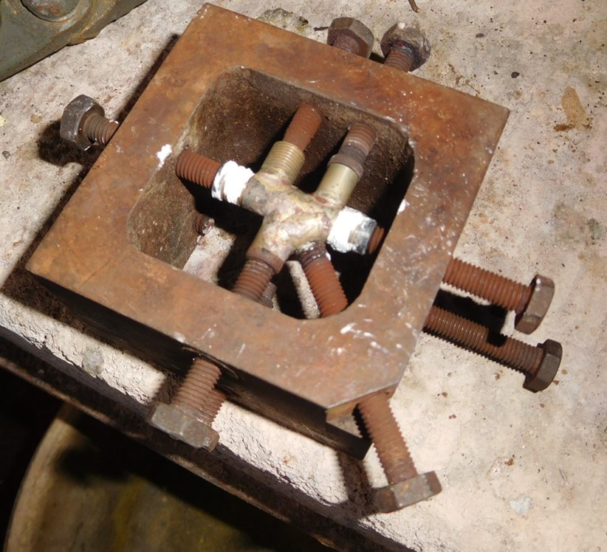
I spent some time cleaning them up, and they looked fine at fine. Except one... The damned thing was cracked! Not just one tiny little crack, but several. What on earth had caused it? Material fault? Dunking too quickly into the pickle? I discounted the last one because it took a while to actually extricate the injector body from the fixture, so it had well cooled down before pickling. Why only one out of the six? All the others were OK
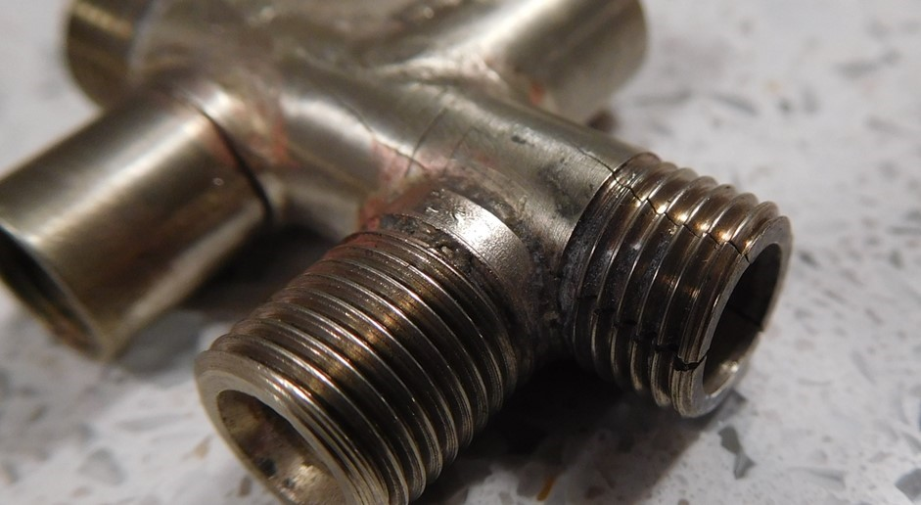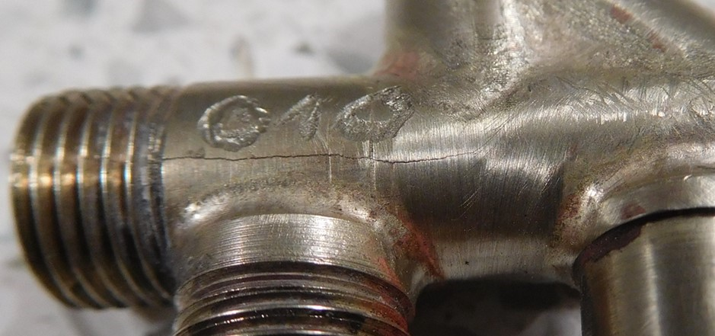
and I’d used the same materials, solder, flux, brazing torch, fixture and pickle! I took another length of bar and put it on the brazing hearth. I heated it to red, immediately pickled it and – nothing. No cracks.
Ah, well; I’ve still got five bodies. I put the duff injector on one side and started to think about the cones. Better make sure of the body lengths before I start, in case there’s a slight adjustment needed... WHAAAT!!! I was shocked; none of the five were anything like the right length – all were at least 0,25mm/0.010” too short.
The nickel brass must have contracted somehow when heated. I made another barrel and measured its length. I then heated it to red, pickled it and measured it again. Same length.
A sudden realisation – I now knew what I’d done wrong. Stupid boy...
What had caused the problem was that my fixture had axially restrained both ends of the injector body barrel. When the barrel had tried to expand with the heat from the torch, it literally had nowhere to go because the fixture hadn’t reached anything like the same temperature, and being a relatively massive chunk of cool-ish cast iron, it wasn’t going nowhere, no time soon. So the barrel simply expanded where it could – sideways – and overstressed itself.
As a check I popped another new barrel (having measured it carefully) into the fixture and clamped it by the ends, making sure the screws were nice and tight. Heat to red heat... remove from fixture and sure enough, it had cracked. And it was a good bit shorter than it had been when turned. Mystery solved!
I then recalled another lesson I’d learned some time before - if you overtighten clamping screws on to brass in a brazing fixture, you end up with dents in the brass where the screw was – and this latest disappointment was just a refinement of that idea. You feel such a fool making the same mistake twice...

Appeal for Information I wonder if you can help. My grandfather
Walter Harrap from Wakefield, who passed away long ago, was a steam engine enthusiast and he made a miniature (1” or ¾” scale) showman’s engine from scratch in his workshop at home.
At some point in the 1950s, he sold the engine to a gentleman within the steam community, who he much admired. My father, a young boy at the time, travelled with him on the back of his BSA Bantam to sell it, somewhere in West Yorkshire, (possibly Pontefract/Castleford?). He also remembers the buyer having a fair organ.
My father has always been desperately sad that it was sold and has longed to find it ever since, perhaps to buy it back for the family.
I have attached photos of the engine with my grandfather and I wonder if you might help spread the word to see if we can find it.

Chris Harrap 07763 620254
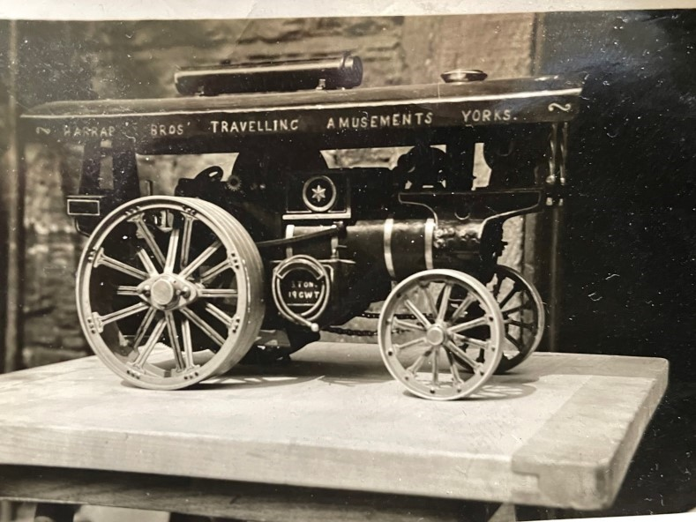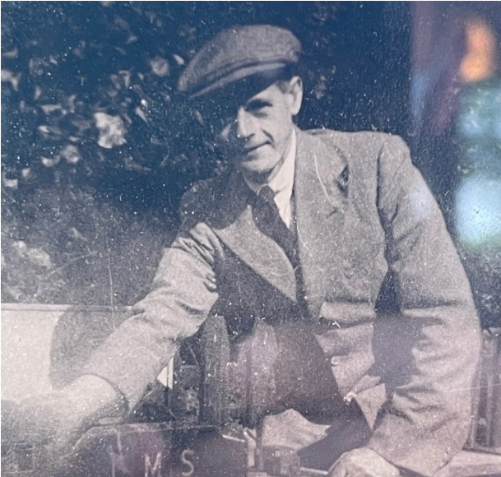
An aid to screw-on chuck fitting Nigel Bennett
To employ a gag by Michael Oxley, who wrote some brilliant humorous articles in ME back in the 1950s, “All of us have lathes, or would like to have them.” Some of us even have more than one, and it is very likely that the spindle noses of your lathes will be of the screw-on variety. Never mind if not; I have a few words to say on other chuck-retaining methods later.
Anyway, if you have more than one chuck, then you have to screw them on and off, and it gets a bit worrying sometimes if (say) you’re screwing on a faceplate with a heavy job affixed to it. How can you be sure that the spindle thread will engage easily – and when will it disengage when unscrewing it afterwards? There is a real risk of the damned thing dropping on to the lathe bed – yet another dent in it – or even bopping your fingers when it unexpectedly falls off, causing the creation of some wonderful language at best.
I pinched the idea from when I saw bayonet-mount SLR cameras in the shops many years ago; one feature I liked was the provision of little red buttons and dimples so that the lens could be quickly aligned before inserting and twisting it into place. I applied it to my screw-mount SLR lenses that I had at the time.
But it worked well with lathes too! What I did was to drill a small dimple on the largest outer diameter of my Myford ML7 lathe spindle and fill it with red paint. Positioning the dimple at the 12 o’clock position I fitted a chuck and marked the chuck backplate where it disengaged (and engaged) the spindle threads. The mark on the chuck was then converted into a dimple and also filled with red paint, so I then knew pretty accurately how to position the chuck to start screwing it on, and when to take a firm grip on it to release it from the spindle – but of course you have to judge when it’s about to release as it might be needing one or two more full turns to get to the disengagement position. (Mine takes just over four full turns to unscrew.) I dimpled all my lathe chucks and faceplates.
When I got the Super 7 it was slightly different; there’s a spindle lock to engage first before removing or fitting a chuck. I didn’t need to bother dimpling the lathe spindle, but just ensured the dimples on the chucks were pointing at the 12-o’clock position when fitting and removing them. I did, however, need to mark the little backgear lever in the headstock so that it always engaged in the same position on the bullwheel, as it can engage in two diametrically-opposite places. Two white dimples:
As a further aid with the Super 7, I drilled an additional dimple on each chuck at the 12-o’clock position to correspond with the engaging point of the spindle lock. These were painted black. Once rotated so the black dimple is uppermost, I only have to move the chuck a couple of degrees either way (if that) to get the spindle lock to engage.
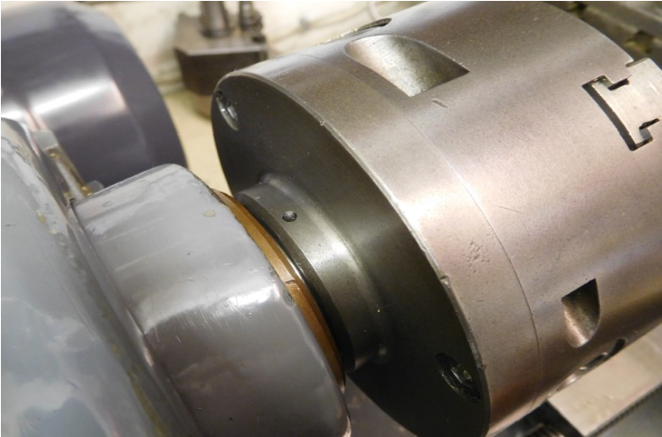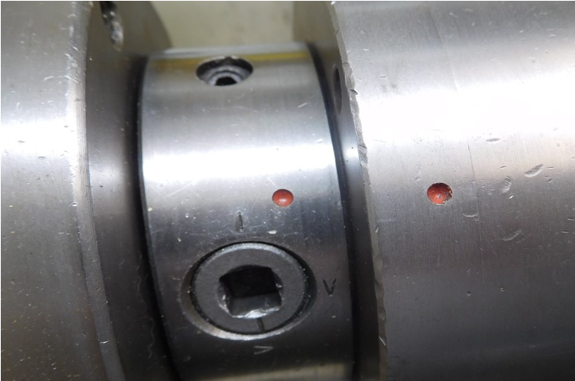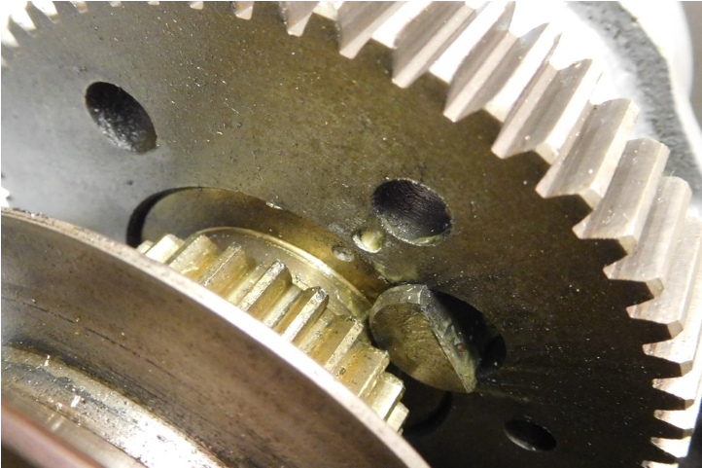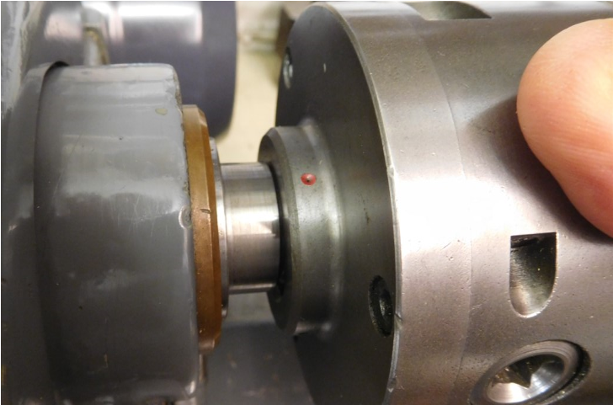
When I got my Boxford 280, it came with a D1-3” Camlock. I dimpled the lathe spindle at one camlock position and also dimpled each chuck adjacent to one particular camlock peg. I get a lot more repeatability as I always fit the chucks in the same orientation and always tighten up the camlocks in a certain order. I imagine the same idea would suit those lathes with bolt-on chucks.
Um... I never did bother doing anything like this on the Unimat 3....
Club Clothing Contact Nigel for details
We have three stock items of club clothing, as we had to add some items to the last order to get the price down!
These are:
2 off Large Short sleeved Polo Shirts
1 off XL Short sleeved Polo Shirt
All at £8.25 each. First come first served; we won't be ordering any more clothing until there is a significant demand.

Society Officers and Committee
President: |  | Arthur Bellamy
Treasurer: |  | Nigel Bennett*
Committee: |  | John Hunt
 |  | Steve Russell*
 |  | Peter Smith
 |  | Mark Batchelor
 |  | Geoff Midgley
 |  | Judith Bellamy
* Denotes Boiler Inspector plus
Martyn Chapman
Newsletter Editor Geoff Botterill

E-Newsletter
Articles are always welcome and can be sent by email to
leedslines@gmail.com

LSMEE Website
https://www.leedsmodelengineers.org.uk

Dates for Your Diary - 1st Quarter 2022
In view of the current Omicron upsurge the committee decided that it would be a better idea to defer restarting meetings until March.

16th March Meeting (Trophy) Night 19:00 - 21:00
Could current holders of the trophies return them before the event or at least on the night. Please note new earlier start time

21st March (Monday) Drax Sports and Social Club
Pre season checks on the track, trailer and club locos, boiler testing and driver competency tests. Starting with an optional breakfast at the club at 9am. Numbers of people requiring breakfast would be helpful.
John Hunt is the contact by email johnhunt4472@gmail.com or by telephone (number on page 11).

Breakfast Club meetings Have resumed on Mondays 09:00-09:30
(Monday 21st March will be at Drax Sports and Social Club)
All meetings will take place at Darrington Golf Club unless stated otherwise and assume no new Covid restrictions are in force
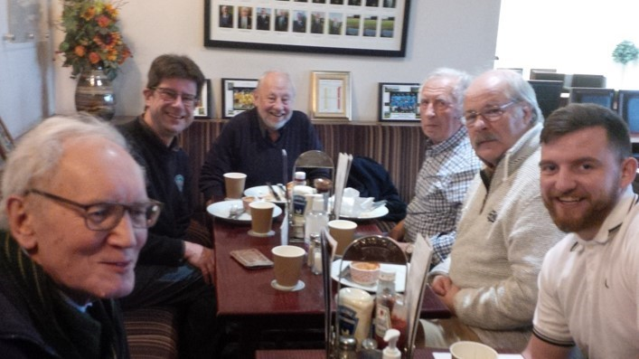

Members are advised to check the club website ‘Events Calendar’ https://www.leedsmodelengineers.org.uk/calendar-1/
for the latest news before travelling

